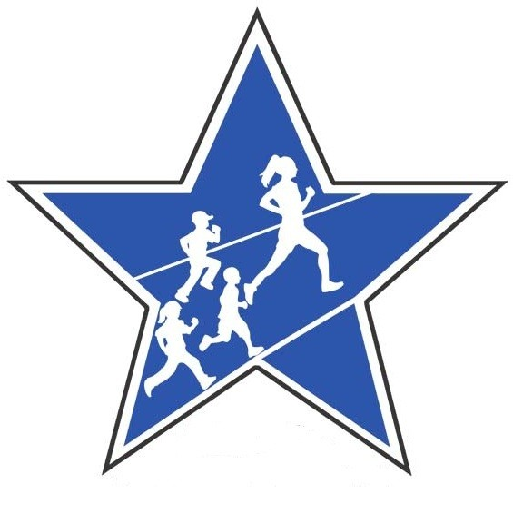
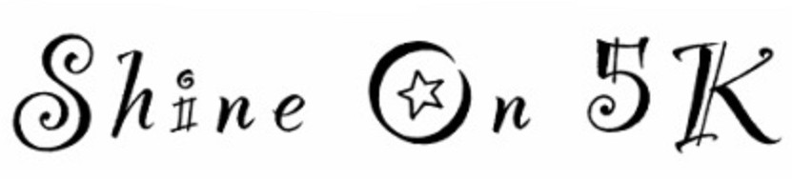
6th Annual

Benefiting the Karen DuCotey Fund for Kids

Race Day – Sunday, May 15, 2016
Location – Lewis S. Mills High School, Burlington, CT

Register In-Person, by Mail or
Online: www.burlingtonctparksandrec.com
By May 2, 2016 to be guaranteed a cotton t-shirt

You may register after May 2, 2016 but will not be guaranteed a T-Shirt
All other registrations will be accepted on Race Day

Check one box below
5K Road Race Entry fee is $20.00, includes cotton t-shirt (by May 2) $25.00 race day.
Fitness Walk Entry fee is $20.00, includes cotton t-shirt (by May 2) $25.00 race day.
Kids Fun Run Entry fee is $15.00, includes cotton t-shirt (by May 2) $20.00 race day.
Dolphin Dash Free (8 years and younger). No t-shirt included.

Please Circle 5K Category below
Youth 13 and under 14 – 18 19 – 29 30 – 39 40 – 49 50 – 59 60 plus

Check or circle your t-shirt size below. Check or circle if you prefer a Dri-Fit upgrade.
SMALL MEDIUM LARGE XL DRI-FIT (ADD $10.00)

You may register online at www.burlingtonctparksandrec.com or in person or by mail to the Burlington Parks and Recreation Department, 200 Spielman Highway, Burlington CT 06013. Checks should be made payable to the Town of Burlington. No refunds. For more info or entry forms go to www.shineon5k.com or 860-673-6789 ext. 7.
In-Person or by mail Race Entry Form
Participants Name:
Address:
Phone: |  |  |  |  |  |  |  | Email:
Age: |  |  |  | DOB: |  |  | Gender: |  |  |  |  | Teacher? Yes No
Additional Donation Included:

Waiver: I know that running or walking a road race could be a hazardous activity and that I should not run unless I am medically able and properly trained. I do so voluntarily at my own decision. I ASSUME ALL RISKS ASSOCIATED WITH RUNNING OR WALKING, INCLUDING BUT NOT LIMITED TO FALLS, TRAFFIC AND CONDITIONS OF THE ROAD. ALL SUCH RISKS BEING KNOWN AND APPRECIATED BY ME. Having read this waiver and knowing these facts and in consideration of your accepting my entry, I for myself and anyone entitled to act on my behalf, hereby waive and release the Town of Burlington, and all sponsors, volunteers, providers of services to the race, their representatives and successors from all claims or liabilities of any kind arising out of my (or entrant’s) participation in this event. I acknowledge and accept that photos will be taken for use on future printed materials or websites.

__________________________________________________________________________________________________Signature of Athlete (Parent’s Signature if under 18 years of age) DATE

Our Cause
The 6th Annual Shine On 5K Run/Walk in memory of Karen DuCotey will be held on Sunday, May 15, 2016. Karen was a teacher at the Lake Garda Elementary School in Burlington for many years as well as a former resident of the community. The race will benefit the Karen DuCotey Fund for Kids, administered by the Main Street Community Foundation to benefit students in Region 10 schools. Proceeds also benefit the Lewis S. Mills High School Scholarship Fund and the Burlington Parks and Recreation Department.

Race Venue
The 5k begins and ends at Lewis S. Mills High School, located at 26 Lyon Road, Burlington, Connecticut 06013. A one mile Kids Fun Run will take place on school grounds and the Dolphin Dash is one lap around the school track. NO PETS, please.

USATF Course
USATF Course ID is CT12025JHP. The course map can be found at http://www.usatf.org/events/courses/search/.

Race Awards
Awards in the 5K Race will be presented to the top three male and female finishers in the following categories:

Youth 13 and Under 14 – 18 19 – 29 30 – 39 40 – 49 50 – 59 60 plus

First Place Teacher, Male and Female. First Place Overall, Male and Female.

Register for the 5K or one mile Kids Fun Run by May 2, 2016 to be guaranteed a Shine On 5k cotton T-shirt.

Race Day: May 15, 2016

Time: 11:30 a.m. – 12:45 p.m. Registration
12:40 p.m. Kids Fun Run (Youth 13 and Under)
1:00 p.m. 5k Run/Walk
1:40 p.m. Dolphin Dash

For information please visit www.shineon5k.com or register online at www.burlingtonctparksandrec.com.

THANK YOU TO ALL OUR SPONSORS!





